**2/27 Minutes**

Project updates: we’re getting ready for the site visit and it makes the most sense to present updates there

This meeting should be used to talk about anything related to the site visit.

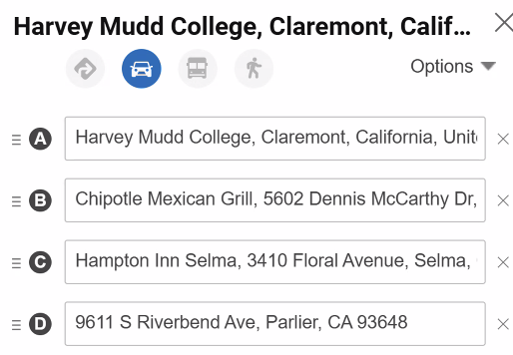

Dr. Backus: trip overview

* Passing through Central valley, an ancient seabed and agriculturally intensive area (nearly half of US fruits and vegetables produced here)
* We’re driving in the evening, and will not be meeting the full group until Tuesday morning
* Keep an eye out for a view of the whole valley just past Frazier Park
* Recommends we stop in Laval truck stop area to eat dinner
* The California Aqueduct is also visible climbing the hill near here
* Be careful to take Hwy 99, not I-5
* Staying in Hampton Inn Selma (3410 Floral Ave, Selma)
* The packing plant we’ll visit is in Bowles
* We should be at the research center by 8:00 on Tuesday morning (9611 S Riverbend Ave, Parlier)
* There is a speed trap on E Manning Ave, so we should watch out
* San Joaquin Research Center
* Dr. Cooper: should I bring my computer? Are you planning to put software on my computer?
  + No–we’ll have you test software on our own computer. We will be asking you to fill out a form, but that can be done on your phone.
* Dr. Backus will have to leave for 2 hours (10-12) Tuesday morning
  + We should plan around giving Dr. Backus time to test our software
  + She will let us stay in the lab until lunch, but we cannot leave except to the bathroom
    - No eating, no drinking in the lab. No food in the lab. We have to be escorted around the building.
    - Photos are allowed in the lab, but nowhere else
  + We’ll order food with Uber Eats on Tuesday and Wednesday
  + We’ll probably talk about publication with Dr. Cooper during this time, and do software testing in the afternoon